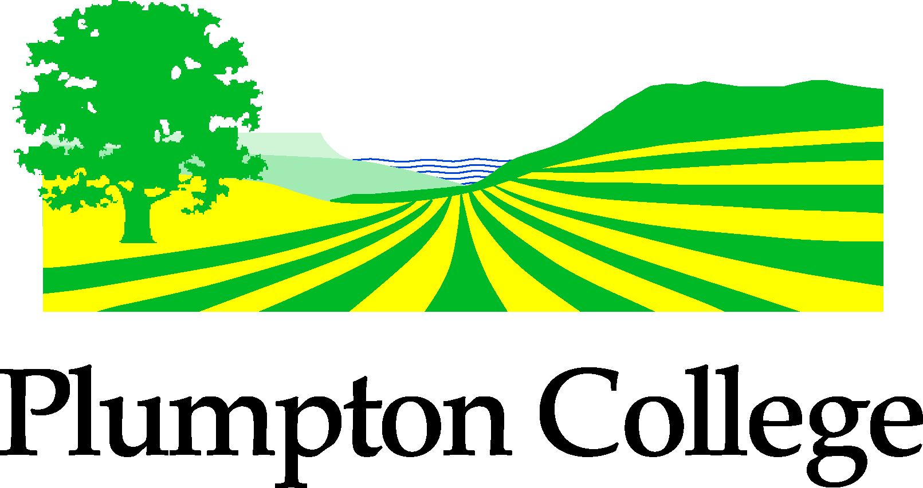
Children’s Rural Education Centre
NEWS & EVENTS 2014
School Visits & Forest School
Educational Farm Visits 2014 – All year round
Literacy Learning Visits on the Farm or in the Woods
Lambing Visits from 10th March – 4th April 2014
Forest School programmes 6-10 weeks
Forest Explorer days
Holiday Clubs: Farm Club, Forest Explorer, Forest Schools
Contact: Deborah Brickell 01273 892096 deborah.brickell@plumpton.ac.uk

Forest School Introductory Seminar 2014
Introduction for Teachers, TA’s, Governors, Farmers & Outdoor Educators.
Monday 3rd March – 9.30am-3pm (Fully Booked)
Monday 28th April – 9.30am-3pm
Contact: Lynn Clark 01273 892096
Forest Explorer – Holiday Clubs 2014
February Half Term – 1 Day – Tuesday 18th February (fully booked)
Easter Holidays -3 Day Holiday Club – 8th,9th & 10th April
May Half Term - 1 Day – Tuesday 27th May
Contact: Lynn Clark 01273 892096

NEW FARM HOLIDAY CLUB – 1 day – Thursday 20th February 2014
Contact: Deborah Brickell – 01273 892096

Primary Food & Farming Awareness CPD Workshop
Wednesday 23rd April 2014
For Teachers and TA’s to explore the value of farming and growing in the curriculum, providing ideas and inspiration to link your classroom teaching with farm-based visits and your own school grounds.
Contact: Deborah Brickell 01273 892096

Plumpton College Open Day - Saturday 10th May 2014 – 01273 892096

