Sent via email

31st December 2020

Dear Student (cc Parent/Guardian)

Important Notification Regarding the Start of Term

In light of yesterday’s government announcement, I am writing to set out the college’s revised plans for the start of term. I am sorry that this all comes at such short notice but I’m sure that you understand the need for us to respond to what continues to be a rapidly evolving situation.

Since the start of the academic year, our priority has always been to achieve the right balance of college based and virtual learning to enable our students and staff to be as safe as possible whilst also ensuring effective and meaningful learning takes place. I believe that for the most part, we achieved this last term, and the progress that you have all made, particularly in light of your engagement with online learning, is both something to be proud of and which will now stand us all in good stead for the coming weeks. As I have always said, our blended delivery model was developed to enable us to scale up or down as necessary to respond to any change in circumstances, which we must now do.

Start of Term

Week commencing 4th January:

There will be no college based lessons this week. All virtual (online) lessons on your timetables that existed before Christmas will go ahead as normal on the same day and time. It is more important than ever that you attend all of these lessons, including your English and maths.

One to one tutorials will also take place with many of you, so please do expect to be contacted by your personal tutor or progress coach to discuss your progress on the course so far, provide feedback on work completed to date and agree SMART targets with you for the coming weeks. You should all continue to work on your assignments and expect to be set additional work to complete on those days when you would have been in college.

Week commencing 11th January:

There will be no college based lessons this week. All of your virtual (online) lessons will take place as normal and virtual lessons will also take place for all of the other lessons on your timetable, except for your practical lessons. You should therefore access MS Teams for all of your normal timetabled (non-practical) lessons during this week and your tutors can guide you through this next week.

Week commencing 18th January:

Based on the current guidance, I would expect and hope to have all of you resuming your normal blended (mix of college based and virtual lessons) timetable in this week.

Examinations

It is the government’s expectation that scheduled exams should still take place during this time. The awarding bodies have therefore confirmed that the scheduled exams taking place for animal management and equine students during the weeks of the 4th and 11th January will still take place at the previously published times. All students should therefore attend these as necessary. I can assure you that the college will ensure that all safety measures are followed as necessary and that exam rooms have been selected which provide sufficient space and ventilation.

I am afraid that we cannot run the entire college bus network for these days but will instead provide shuttle buses from Lewes and Hassocks railway stations. These will leave at 8.45am on the morning of those exams and return at lunchtime. You will not need to purchase tickets or pay for this service.

Residential students

As a result of the above, residential students will now move back into residence from Sunday 17th January. Further details of that will be provided by our Student Services team in due course.

Covid Testing

The college will be proceeding with its plans to have lateral flow testing in place for students and staff from Monday 18th January. I will share more details of what this is, how it works and who it will be for in due course, but needless to say at this stage, please be reassured that it can only help to ensure we minimise risk of transmission further.

We are currently working on mobilising a team of staff to administer this and would ask that if any student or parent has friends or relatives with relevant experience in any form of medical setting or would be willing to volunteer to help with the administration side, please do get in touch with our Deputy Principal, James Hibbert. (james.hibbert@plumpton.ac.uk)

I hope this provides you all with sufficient clarity regarding the next two weeks. I apologise again for the disruption this will cause you, but ask that you all please maintain your commitment to your studies over the coming weeks, despite the very difficult times happening around us.

I know that you enrolled onto your course because of your passion for your subject and your desire to gain the skills and knowledge to progress into the workplace. That desire and ambition to work in the industry you have chosen, or simply to better yourself is more important than ever. I encourage you to use it to keep yourself motivated, keep thinking about your future and the wonderful opportunities that will be available to you and for now, to keep focused on your attendance, your assignments and being your best self.

Please don’t hesitate to contact me directly if you have any queries relating to the above or if the college can provide further support still in supporting you to get online in any way. (Jeremy.kerswell@plumpton.ac.uk)

Stay safe and I look forward to seeing you back at college soon.

Yours sincerely

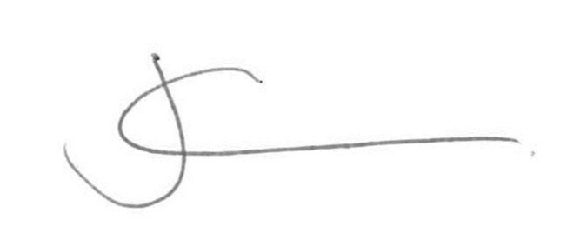

Jeremy Kerswell
Principal

